**Edit Function in Language Route**

**1.** The purpose of this documentation is to show the steps and functionalities of the edit function for the language routes.

This is the interface of the first page

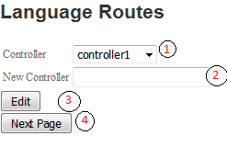

**1**. This is the dropdown populated by the controller column in the database.

**2.** This is the field where the user will input the desired revision of the controller.

**3**. This button will be the one to process the editing.

**4.** This button will redirect the user to the action edit page.

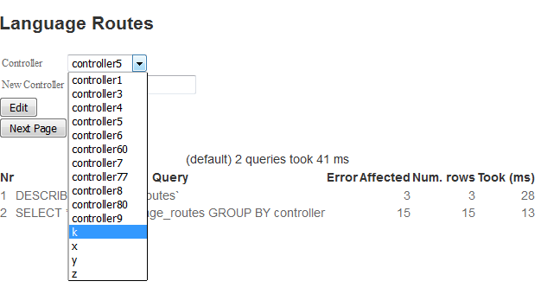

The drop down for the ‘*Controller*’ is populated by the contents that are stored in the database.

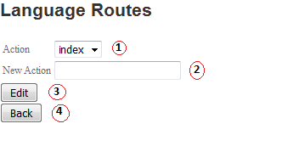 **1.** The contents of this dropdown will be determined by what ‘*Controller*’ was chosen.

The purpose of this is to assign all the action for the controller that was chosen even if the controller has the same name.

**2.** The user will input the new action in this field.

**3.** This button will be the one to process the editing.

**4.** This button will redirect the user to the controller page.